Exp No: 25
PRODUCER–CONSUMER PROBLEM USING SYSTEMC
AIM:
To implement and simulate the Producer–Consumer problem using SystemC

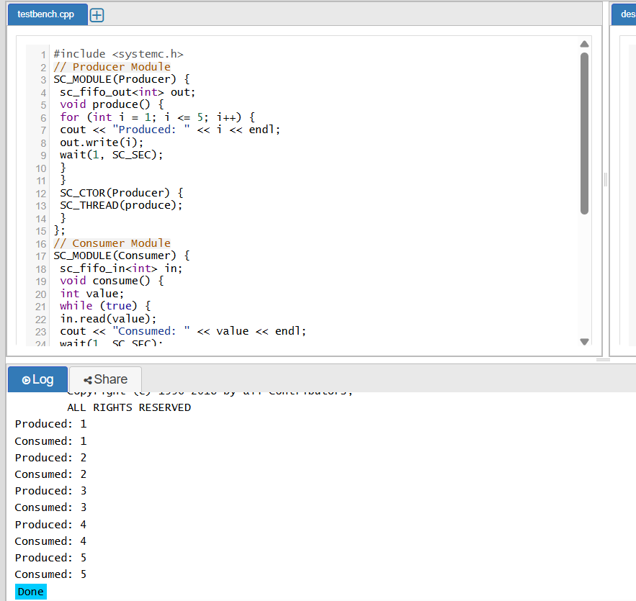
RESULT: Thus, the Producer–Consumer problem was successfully implemented and simulated using SystemC. Proper synchronization between concurrent processes was achieved using FIFO communication

